**DAILY ONLINE ACTIVITIES SUMMARY**

|  |  |  |  |  |  |  |  |
| --- | --- | --- | --- | --- | --- | --- | --- |
| **Date:** | **08/06/2020** | | | | **Name:** | **Hanan Saleem baji** | |
| **Sem & Sec** | **4th SEM 'A' Section** | | | | **USN:** | **4AL18CS024** | |
| **Online Test Summary** | | | | | | | |
| **Subject** | | **Maths** | | | | | |
| **Max. Marks** | | **30** | | **Score** | | **18** | |
| **Certification Course Summary** | | | | | | | |
| **Course** | **1.Ethical hacking** | | | | | | |
| **Certificate Provider** | | | **1. Great Learning Academy** | **Duration** | | | **1. 3 hour** |
| **Coding Challenges** | | | | | | | |
| **Problem Statements:**   1. Write a Java program to check whether the given matrix is square or not. 2. Write a c program to generate all the sets of partition of n numbers beginning 1 and so on.     .  For example | | | | | | | |
| **Status: completed** | | | | | | | |
| **Uploaded the report in Github** | | | | **Yes** | | | |
| **If yes Repository name** | | | | 1. https://github.com/saleemhananbaji/**java-coding.**   **2.https://gitHub.com/saleemhananbaji/C-coding.** | | | |
| **Uploaded the report in slack** | | | | **Yes** | | | |

Online test details:

As per the online test ,today maths exam was conducted and I scored 18 in the test.

Sanpshot:

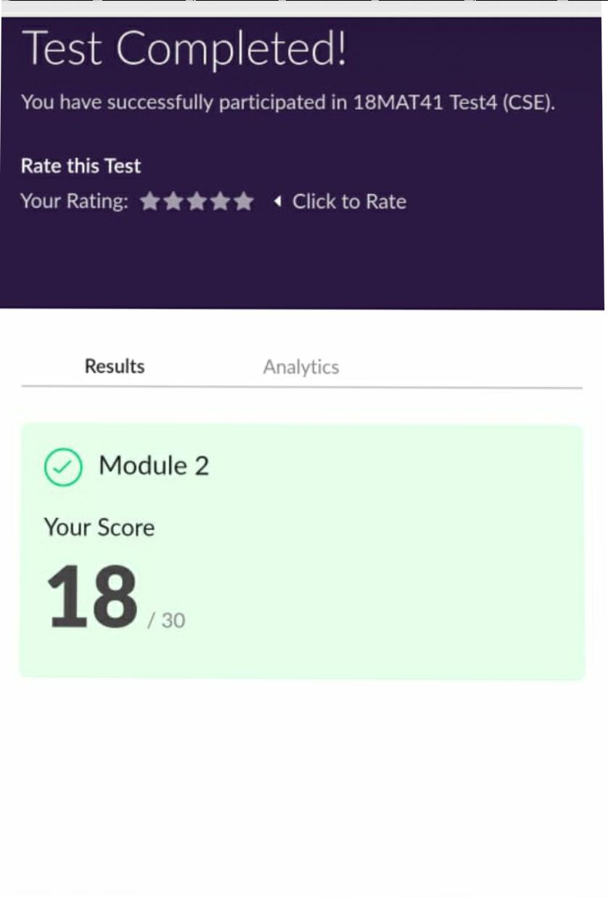

Certification course:

As the continuation of online course I was able to complete the domain and process implementation in ethical hacking.

Snapshot:

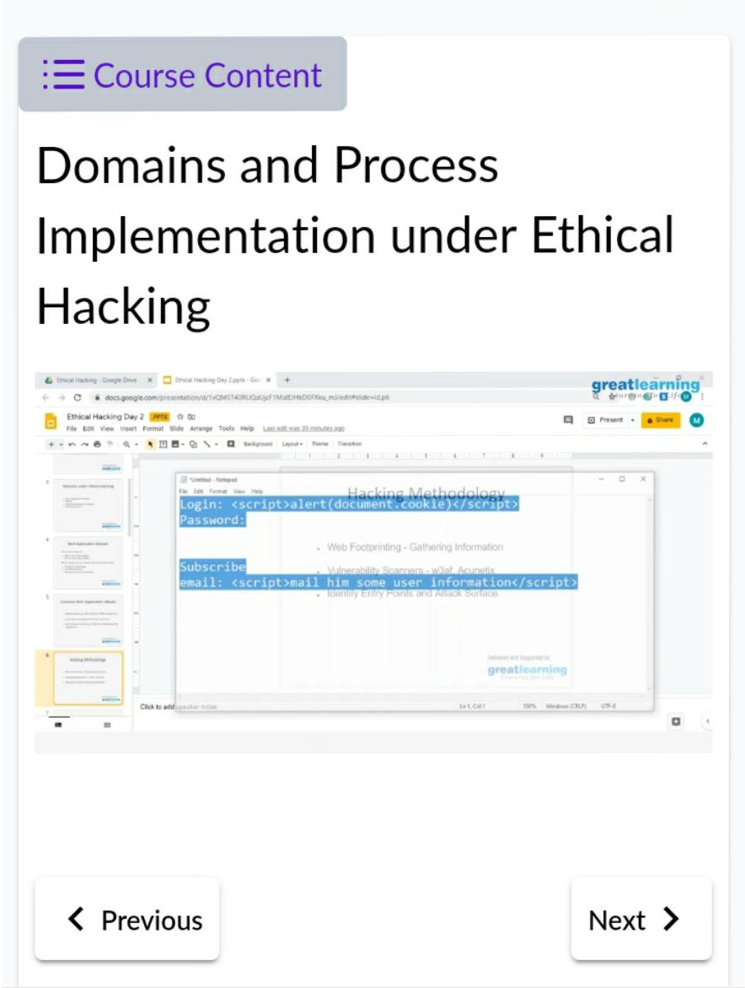

CODING CHALLENGES DETAILS: Problem statements

**Problem Statement 1: Write a Java program to check whether the given matrix is magic square or not.**

Solution: Uploaded it in github

Snapshot:

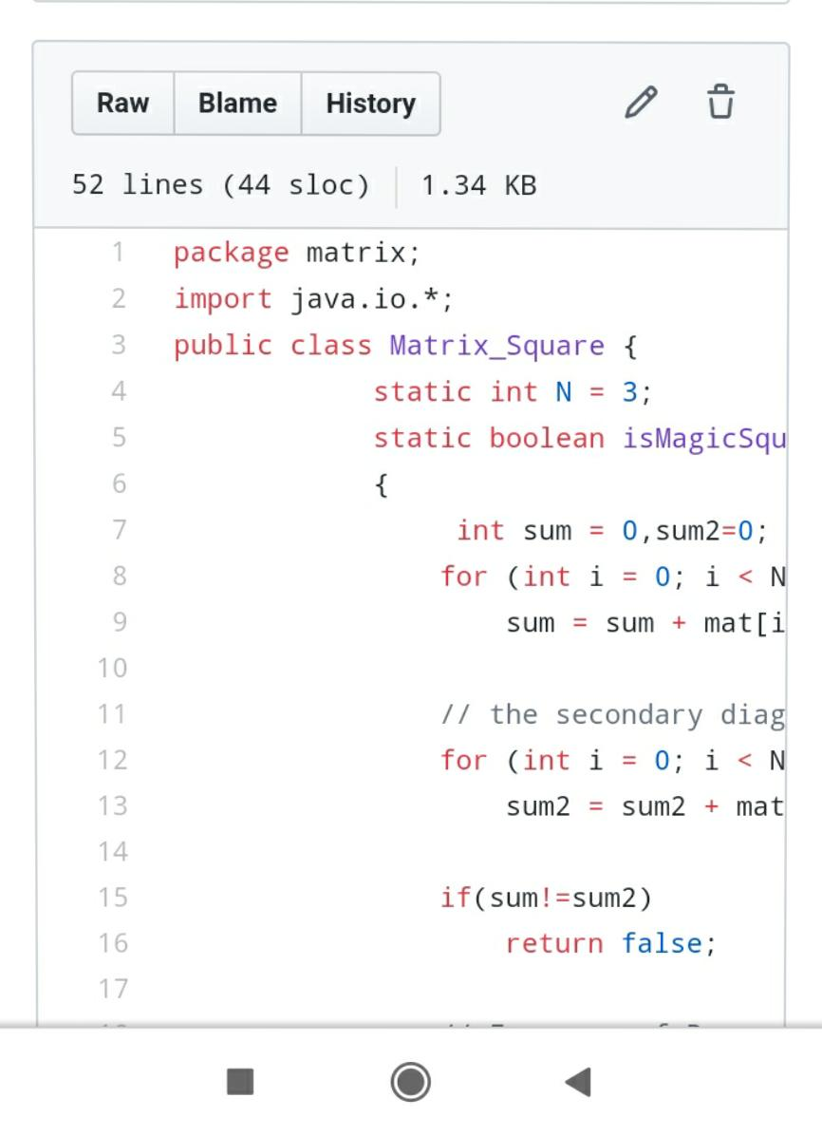

**Problem Statement 2:Write a c program to generate all the set partition of n numbers beginning from 1 and so on.**

Solution: Uploaded it in github

Snapshot

